**Project 1 report writing**

**Business problem and the insights derived and research questions answered through the Exploratory Data Analysis Process.**

**Business Problem:** Alpha Dreamers Banking Consortium faces a high rate of defaults on personal loans, negatively impacting their profitability and business stability. They aim to minimize this risk through data-driven insights and improved loan approval processes.

**Insights from Exploratory Data Analysis**

**What are the demographic characteristics (age and income) of borrowers who are most likely to default?**

**Line graph showing distribution of age by income**

Understanding the income distribution by age can help the bank target their marketing and outreach efforts more effectively. By focusing on age groups with higher income and lower default rates, they can attract borrowers with a greater ability to repay, potentially improving overall loan performance.

Below is a distribution of Age by Income

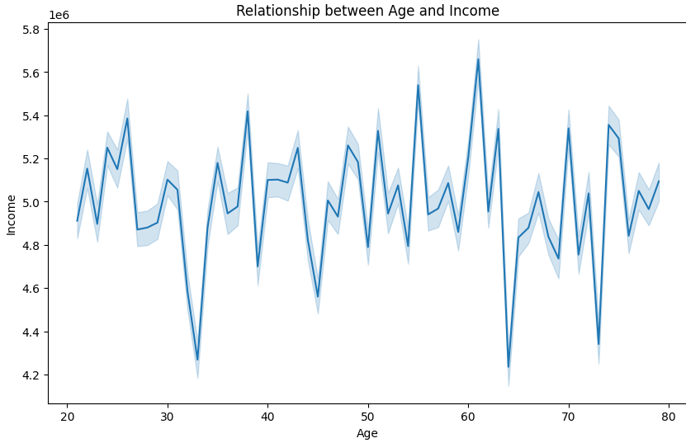

It was discovered that age has an impact on income, the older the person the more the income.

**Are there certain income levels or professions that pose a higher risk of default?**

**Line graph showing income distribution by experience**

Experience often translates to job stability and higher earning potentialwhich are crucial factors in a borrower's ability to repay a loan. Analyzing the income distribution across different experience levels can indicate potential risk segments. Borrowers with lower experience and lower income might have a higher risk of default

**Below is a graph showing income by experience**

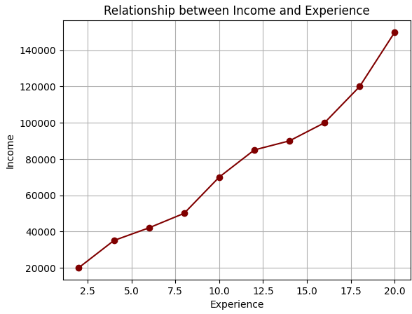

.According to the graph people with many years of experience have higher salaries.

**Bar chart showing the distribution of professions**

Certain professions may carry higher financial risks or income instability due to factors like project-based work, seasonal fluctuations, or economic sensitivity. Analyzing the distribution of professions among borrowers with high default rates can reveal professions potentially associated with increased risk. By understanding these patterns, the bank can adjust loan approval criteria, offer alternative loan products, or provide financial literacy resources to borrowers in these potentially risky professions.

**Below is a distribution of professions in our database**.

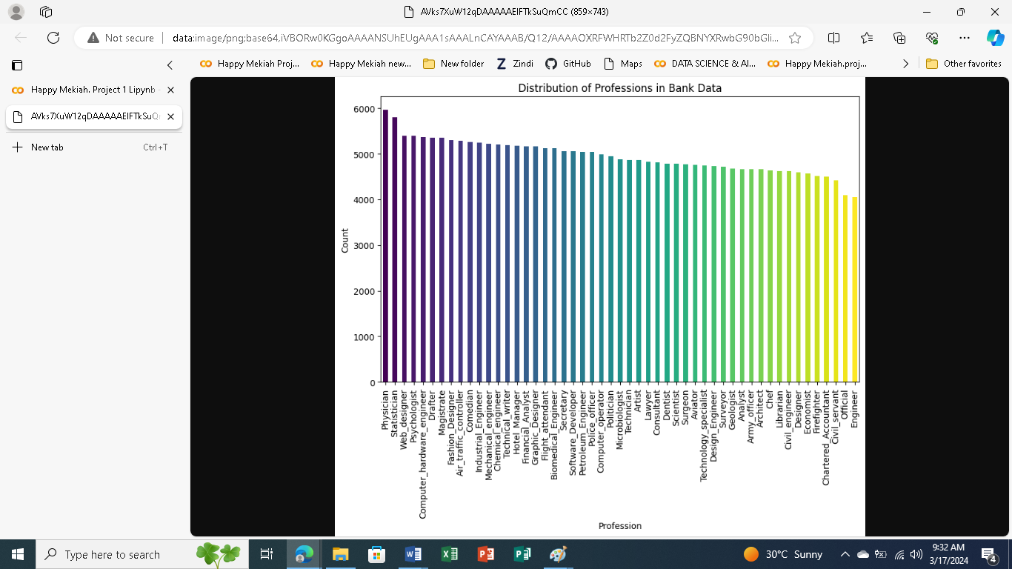

There are many Physicians and few Engineers according to the graph.

**Is there a difference in Risk Flag between married and unmarried borrowers?**

**Bar plot showing average risk by marital status**

Married couples often share finances and resources, potentially leading to greater financial stability and better ability to manage loan repayments compared to single borrowers.Individuals with dependents might have additional financial responsibilities, potentially impacting their ability to prioritize loan repayments.

**Below is a distribution of marital status by riskflag**

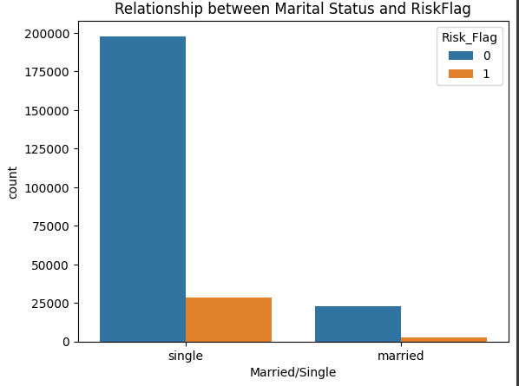

According to the graph single people pose a higher risk than married people.

**Is there a correlation between the features Income, Age and Experience?**

**Heat Map showing correlation matrix between income, age and experience**

The heatmap quickly reveals whether age, income, and experience are positively or negatively correlated with one another. Are younger borrowers with less experience likely to have lower income, potentially signifying higher risk?

**Below is a correlation of features**

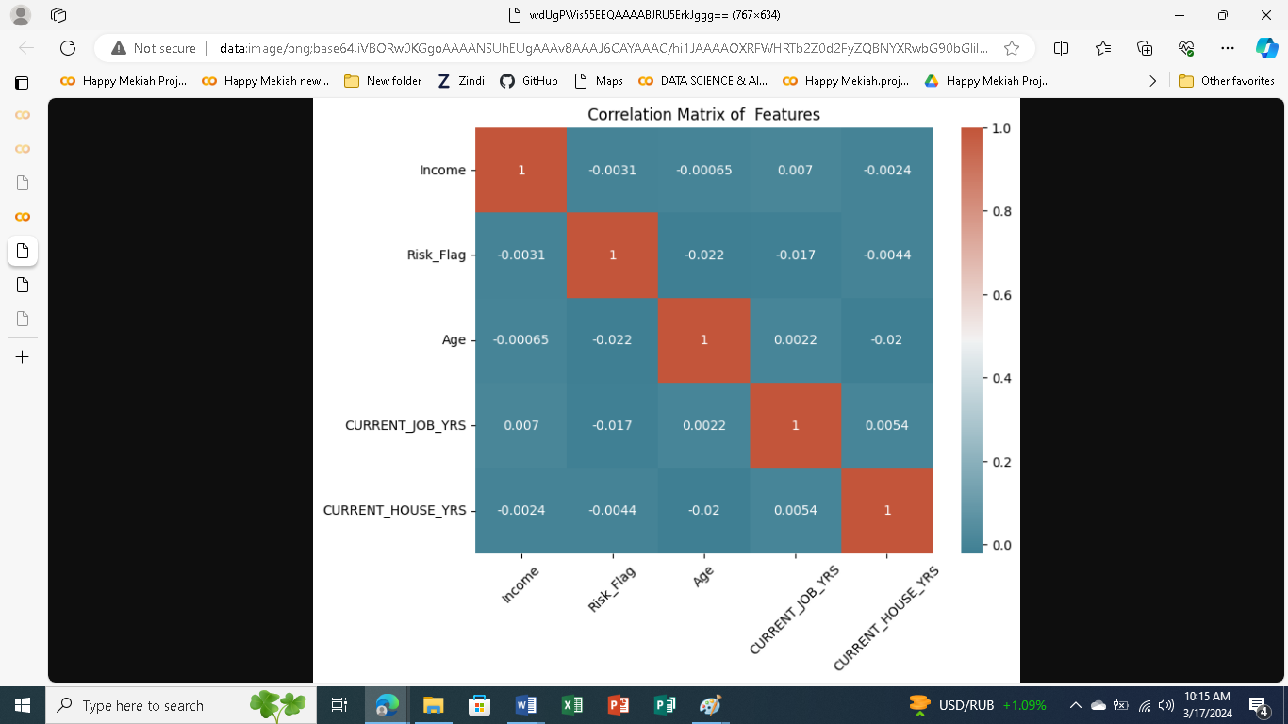

**Do house owners tend to have a lower, higher, or similar distribution of risk flag scores compared to non-house owners?**

**Pie chart showing risk flag distribution by house ownership**

Based on the risk profile of each segment (homeowners and non-homeowners), the bank can develop loan products with appropriate interest rates, repayment terms, and loan amounts aligned with their affordability and risk profile.

**Conclusions**

By analyzing these different aspects through visualizations, Alpha Dreamers can gain valuable insights into the characteristics of borrowers and loans most susceptible to defaults. This information can then be used to develop more accurate risk assessment.models, refine loan approval criteria, and implement targeted interventions to minimize defaults and improve profitability.